INSTRUCTIONS FOR THE UNIVERSITY OF OKLAHOMA FOUNDATION'S ONLINE SCHOLARSHIP DISBURSEMENT REQUEST FORM

INSTRUCTIONS FOR THE UNIVERSITY OF OKLAHOMA FOUNDATION'S ONLINE SCHOLARSHIP DISBURSEMENT REQUEST FORM 1
Preparer Access: 4
Choosing a Fund: 7
Choosing the sponsor: 8
Pre and Post Approver Selection (Optional): 9
Header Information: 10
Hold All Semesters Checkbox: 10
Title or Comment: 10
Date of Request: 11
Email me (the preparer) a copy of this form once it has been submitted. 11
Eligibility Criteria: 11
Review Committee: 11
Advertisement: 11
Saving the form: 12
Adding Students: 13
Requesting a Waiver: 15
Requesting Signatures: 16
Adding, Changing, and Removing Signatories: 18
Changing Primary and Counter Signatories 18
Changing Pre and Post Approvers 19
Adding Pre and Post Approvers 20
Removing Pre and Post Approvers 21
Printing Check Stubs: 22
Adjusting the Print Settings in Internet Explorer 26
Adjusting the Print Settings in Firefox 29
Adjusting the Print Settings in Chrome 31
Adjusting the Print Settings in Safari 33
Sponsor Access: 34
Signature Request Email 34
Signing the Form 35
Quick-Signing the Form 38
Declining to Sign 42
Clearing the Signature Declined status 44
Changing your Digital Signature 45
Proxy Signature Authority: 47
Search/View Processed Forms 53
Form ID: 55
Fund Account: 55
Student ID: 55
First Name: 55
Last Name: 55
Semester: 55
Submitted on: 55
System Generated Notifications 58
Preparer Notification Preferences 59
Sponsor Notification Preferences 63

Preparer Access:

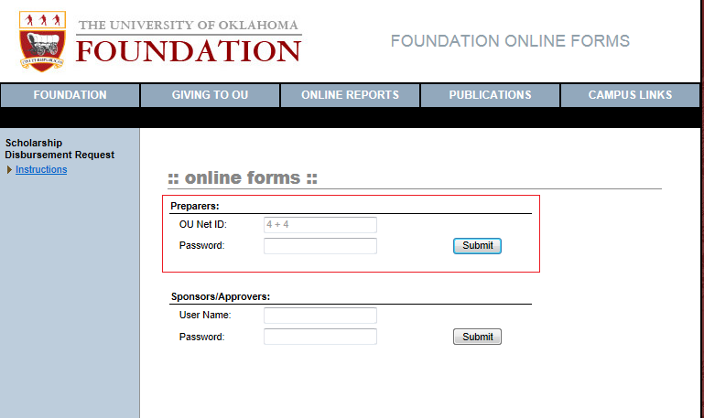

Form preparer's sign in to the site using their OU Net ID and password in the top section labeled 'Preparers:'.
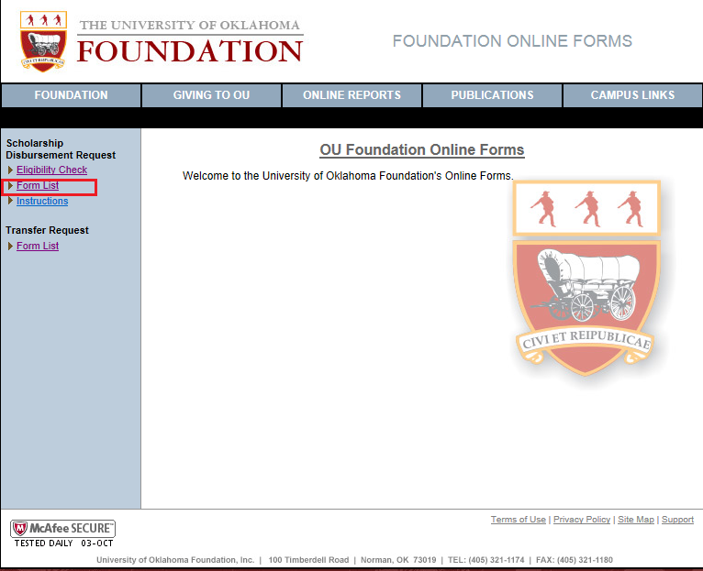
Choose 'Form List' from the Scholarship Disbursement Request menu.
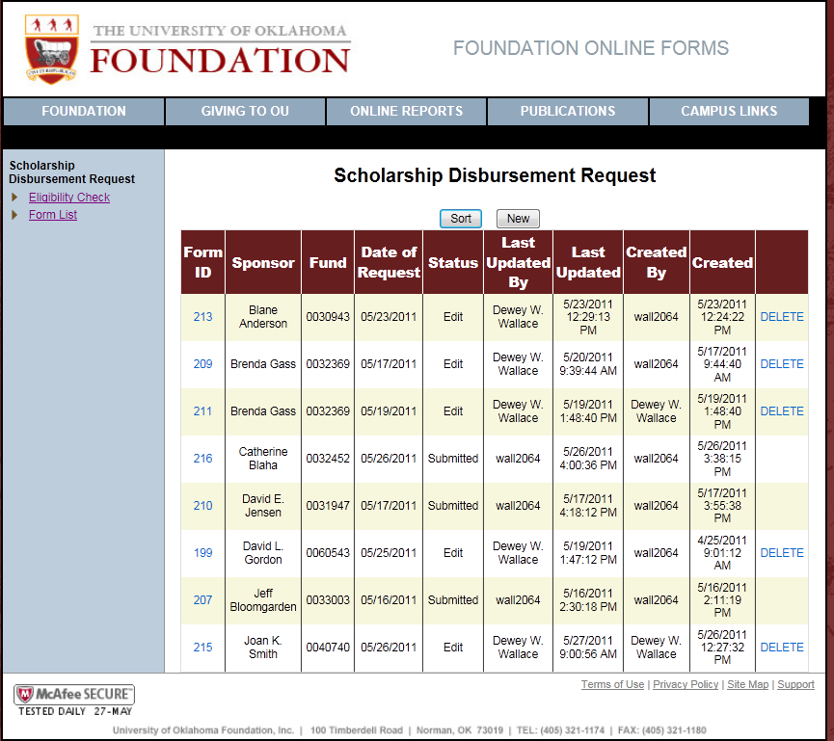
You are presented with a list of current Scholarship Disbursement requests, a sort button and a button to start a new form. Click the 'New' button to start a new request.

Note: Click on the form id to view an existing form.

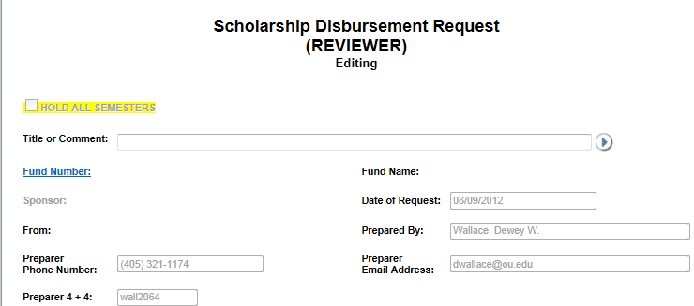

Choosing a Fund:
Click the link 'Fund Number' to display the fund selection dialog. Begin typing a fund title or fund number into the text box. Do not tab out of the box or press enter; wait for the list to appear and select the fund from the list. Once you have selected a fund, click 'OK' to accept. You may select a fund using the mouse or the arrow keys and enter key.

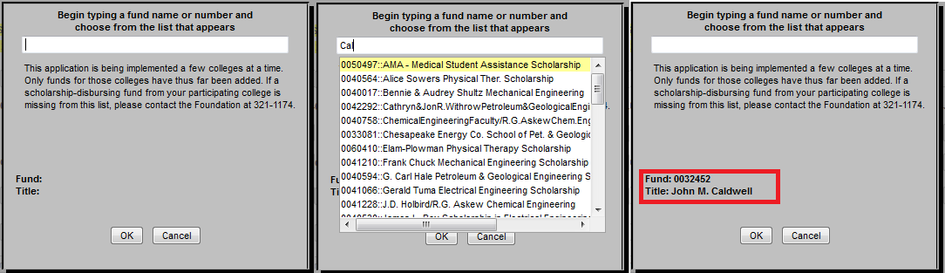

Choosing the sponsor:
Once a fund has been selected, the sponsor selection popup will display.
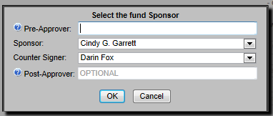
Pre and Post Approver selection is optional. If you do not wish to select a Pre or Post approver for your form, select the primary and counter signers, click the 'OK' button and skip the next section of the instructions. The primary and counter signers are required.

Pre and Post Approver Selection (Optional):
Pre and post approvers are optional signatories, such as a department head or dean, which you wish to approve this form before or after the fund sponsors.
To select a Pre or Post Approver, begin typing the person's name in the appropriate text box. Once you have typed at least four characters and paused, without leaving the field or pressing enter, a select list will appear with the potential matches if any. Select the desired name from the list. You must select the name from the list, typing the name in the text box will not select the approver. If the approver you are searching for does not appear in the list you will need to contact the Foundation to have them setup.
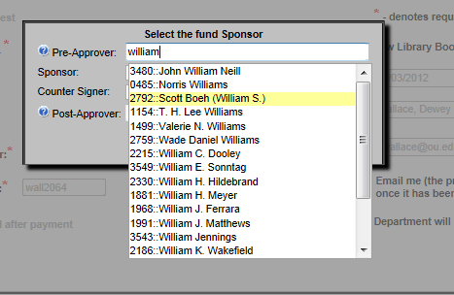
Once a pre and/or post approver has been added to the form they will appear in the signature section with the primary and counter signing sponsors. They will have the same ability to sign or decline to sign as the fund sponsors.

Header Information:
At this point the rest of the form becomes unlocked, allowing you to continue filling out the request.

Hold All Semesters Checkbox:
The hold all semesters check box allows you complete a scholarship payment request, including signatures and prevent the Foundation from releasing the payment. The Foundation will not process the form until the preparer takes the form off of hold. When the form is taken off of hold, the form is re-validated with the information currently on file. Forms that have the Hold All Semesters check box selected will appear in the form list with a yellow background.

Note: Using the hold checkbox is not necessary when entering scholarships early. For example, the Foundation will not process a fall scholarship that is entered during the spring semester. The scholarship will be processed when fall scholarships are normally processed.

Title or Comment:
This is a convenience field for the colleges. Anything entered here will appear at the top of the form once it is generated as a PDF document.

Date of Request:
The date of request is a system generated date. It will be the date that the form is ready for the Foundation to process. This will be either the date of the last signature or the date the form is taken off of hold.
Preparer Information:
The preparers name and phone number have been pre-populated.
Preparer email and 4 + 4 are pre-populated and cannot be changed when logging in via OU Net ID.

Email me (the preparer) a copy of this form once it has been submitted.
This checkbox has been removed. The preparer always gets a copy of the form emailed to them at form submission or processing.

Eligibility Criteria:
List the criteria used to determine the student's eligibility for this scholarship.

Review Committee:
List the members of the committee or individuals who reviewed the student application(s).

Advertisement:
Select at least one of the following options. If other is selected a comment is required.

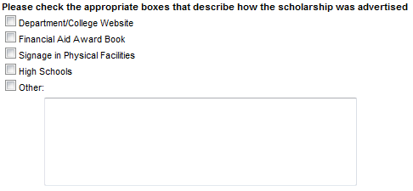

Saving the form:
Once all of the above has been completed, you may save the form. The form can be saved by clicking the save button in the floating command box at the top right of the form.


Note: This is a web application. If the session with the web server expires and the form has not been saved, all work will be lost. Web sessions will generally expire after 20 - 30 minutes. Save frequently to avoid data loss.

Adding Students:
Students are added by clicking the 'Add Student' or 'Import' button.
Importing Students
If you have multiple students receiving a scholarship from the same fund, you can import a list into the request form, rather than having to type in each student ID separately.
- All students on a form must be on the same campus. If you have students on multiple campuses, put them on separate lists, or input them separately.
- If scholarship amounts are all the same, input one student into the form with the amount. When remaining student fields are populated, the amount will be automatically copied.
- You can also change the amounts after the student fields are populated.
- Prepare a list of student ID numbers, either in a plain text document, one ID per line, or saved as a CSV document.
- You may have no more than 25 ID numbers per list but, may import multiple lists.
- Click the Import Button.

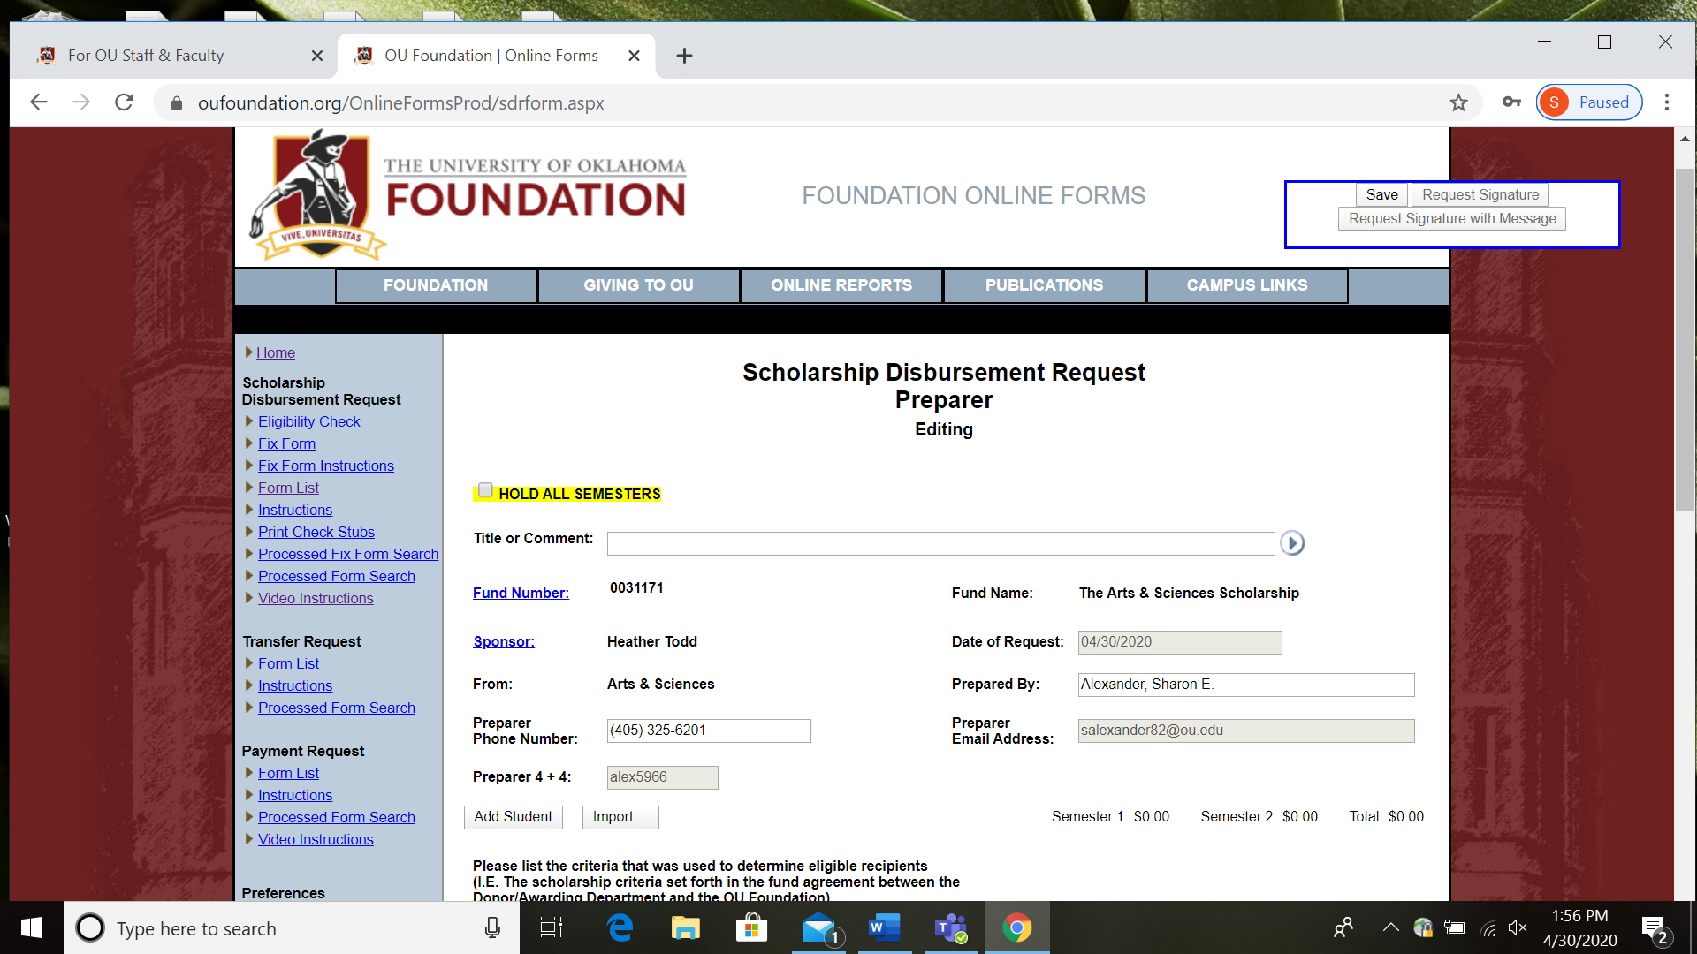

Adding Students Manually
Clicking the 'Add Student' button adds a new student row to the form.
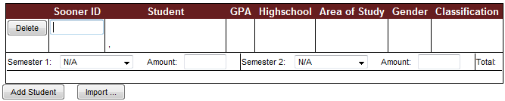

Type a Sooner ID into the Sooner ID text box and tab off of the field or press enter. This causes the student associated with the Sooner ID to be retrieved.
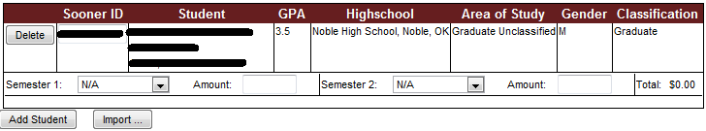
NOTE: the GPA will only display for fund sponsors.
The semester and amount are entered now. Up to two semesters may be selected for any student.

The form should now be saved. At each save the student data is checked for updates from the University and the student is validated for eligibility based on the rules set up for this fund.

If the student fails validation, one or more errors will be displayed. The student should be deleted from the form, a waiver requested, or the data for the student should be corrected.
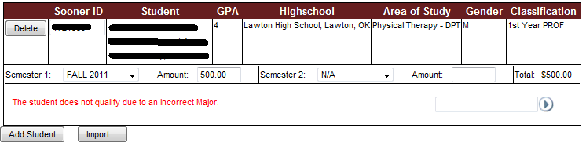
If the student is missing the permanent address you will get a result like this:
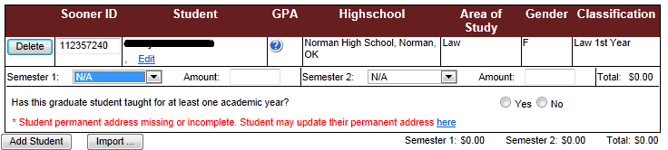
You may have the student enter their permanent address in Ozone and it will be transferred to the Foundation during the next data refresh. Alternatively, you may click the 'Edit' link in the address field. You will receive a popup allowing you to enter the address.
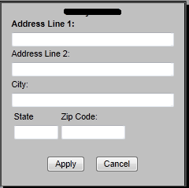

Once you have entered a complete address here you may continue. If a new and complete address is provided by Ozone, it will over-write any address you have entered.

Requesting a Waiver:
To the right from each error message is a text box and image for requesting a waiver. You may type into the text box the reason a waiver should be granted or click the image to open a popup with a larger text box.

Waiver request text box and image:


Waiver request popup:
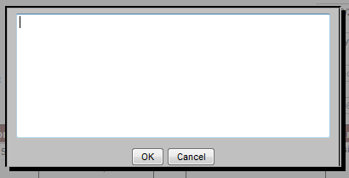

Requesting Signatures:
Once all students have been successfully validated and all errors have waiver requests, the floating command box will have two new buttons; 'Request Signature' and 'Request Signature with Message'. Clicking 'Request Signature' emails the sponsor(s) a notification that there is a form for them to review and sign. The notification email contains a link to the form.
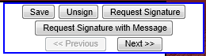
Clicking 'Req. Sig. w/Msg.' will allow you to send a message along with the request. When the message popup appears, enter a maximum of 500 characters and click 'OK'. The message will appear at the top of the email with the normal request information following. If you check 'Send to All Signatories', the message will be saved and sent along to all signatories as the form is signed and the system generates requests, otherwise, the message gets sent to sponsors in the current request only. Once a message is saved, un-checking the checkbox and sending a request or sending a request via the 'Request Signature' button will clear any saved message.
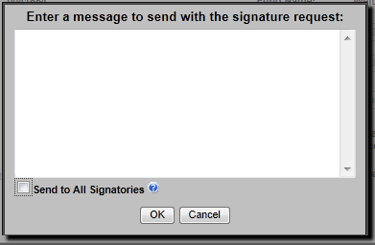

Once the notification has been sent, the signature section is updated with the last notification date, time and number of times notified.
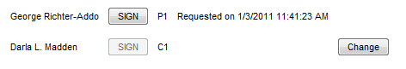

The preparer will be notified via email as each required signature is received and when the form is submitted to the Foundation.

Adding, Changing, and Removing Signatories:

Example Signature Block
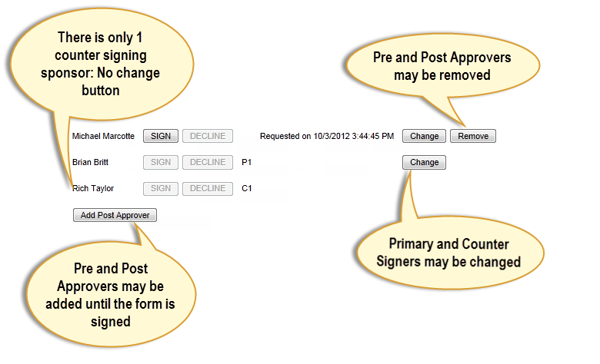

Changing Primary and Counter Signatories
Primary and counter signers may be changed if there are alternate choices available. Click the change button next to the signatory you wish to change.
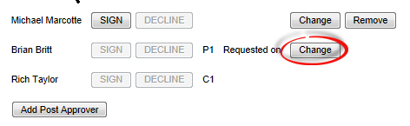

The alternate sponsor(s) will display in the dropdown for selection. Select the sponsor you would like to change to and click OK or click Cancel to make no change.

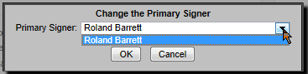

Changing Pre and Post Approvers
Clicking the change button next to a pre or post approver will display a popup to allow you to type the name of a new approver. Similar to the original selection dialog, you need to wait for the dropdown to appear and select them from the list.
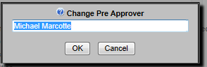
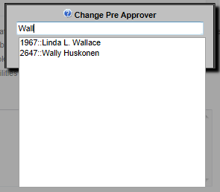
If you delete the approver name from the dialog and click the OK button, the approver will be removed. Clicking Cancel will keep the approver that is already selected.

Adding Pre and Post Approvers

If the form has been saved and has not been signed, you may add pre and post approvers by selecting the appropriate add button in the signature block.
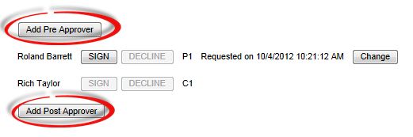
The Add Pre or Post Approver dialog box displays.
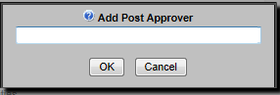

Begin typing the name of the desired approver and select them from the dropdown when it appears.
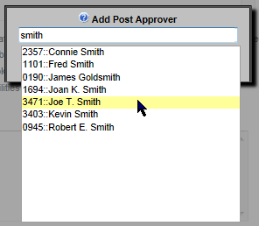

Removing Pre and Post Approvers
If no signatures have been received, you may remove pre and/or post approvers by clicking the remove button next to their signature area.
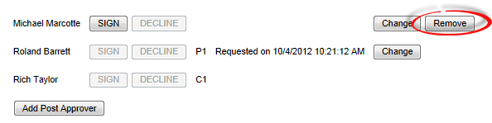
You will be prompted to confirm that you want to remove the approver.
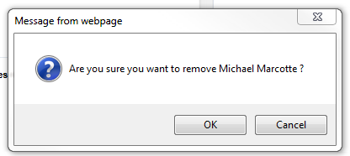
Click 'OK' to remove the approver or 'Cancel' to make no changes

Printing Check Stubs:
Any logged in user may print check stubs for paid scholarships.
Preparers may print for any form they prepared.
Sponsors may print for any scholarship from a fund for which they have primary or counter signature authority.
Reviewers may print for any fund associated with any college or department for which they have been set up as a reviewer.

Choose the 'Print Check Stubs' option from the menu in the online forms application.
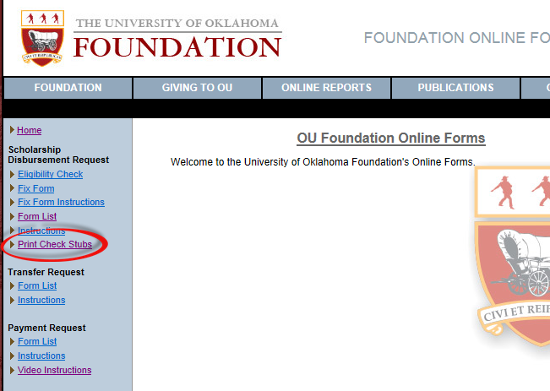
This is where you query for the check stub(s) you wish to print. At least one of the query fields must be entered and you may enter more than one. Click the submit button to execute the query.
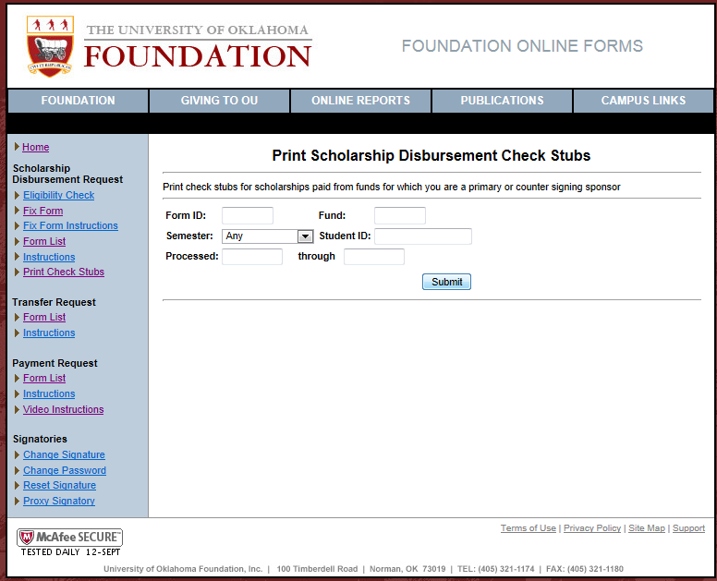

Once the results have been returned, select the print checkbox next to each item you wish to print. You may select the 'All' check box in the header row to select all of the checkboxes. Click the 'Print Selected' to generate the check stubs.
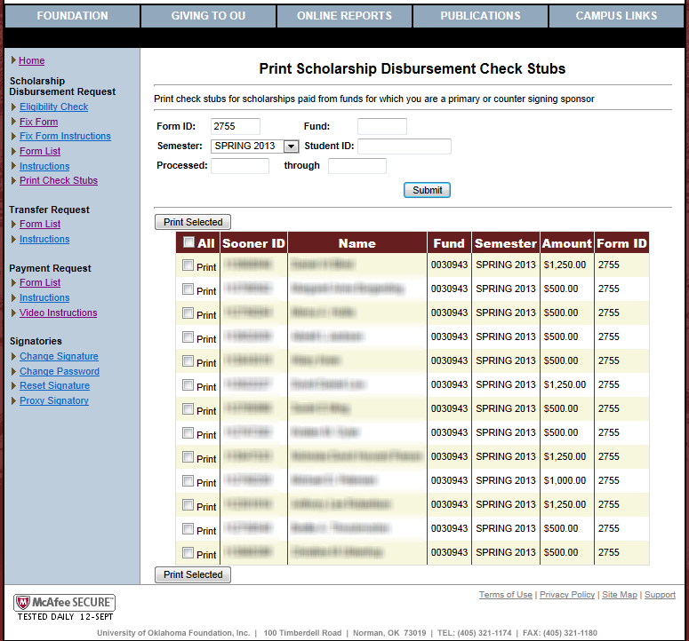

The application will return a web page that you may print that will result in one check stub per page.
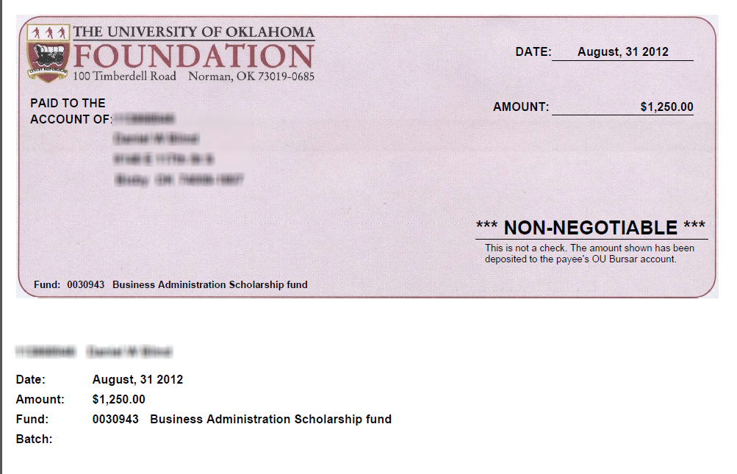

For the best results you may need to adjust the print settings in your internet browser.

Adjusting the Print Settings in Internet Explorer

To adjust the print settings in Internet Explorer 9, click the in the upper right corner of the toolbar. Choose 'Print' then 'Page setup' from the menu.
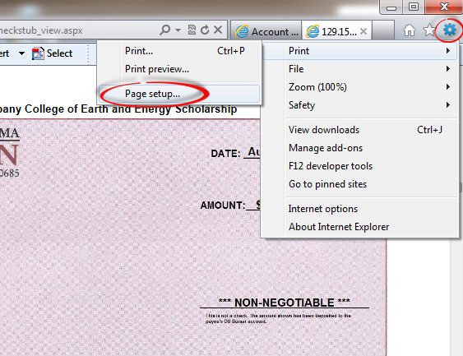

Alternatively, choose 'File' then 'Page setup' from the menu.
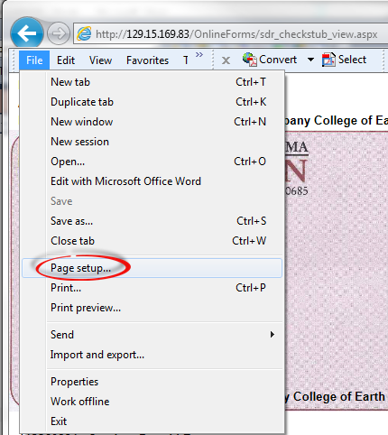

Set the 'Page Setup' as follows to prevent the date, Url, and page numbers from printing at the top and bottom of the page. The margin values shown worked well for the check stubs during testing. You may need to try different values depending on your printer.

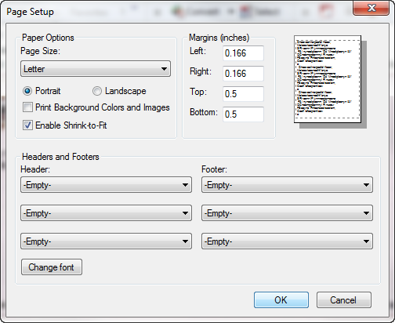

Adjusting the Print Settings in Firefox

To adjust the print settings in Firefox, open the menu and choose 'Print' then 'Page setup'
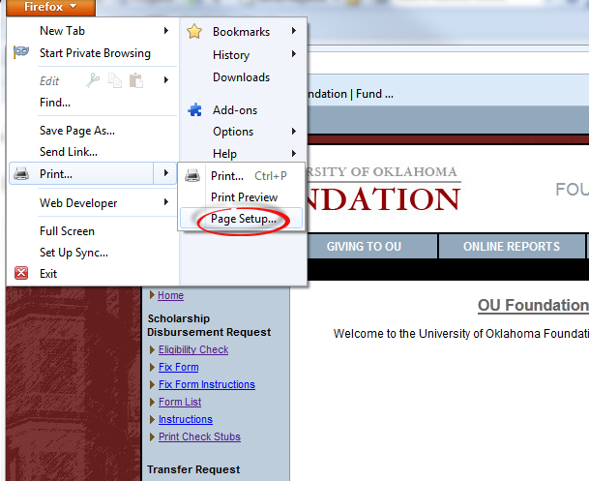

Change the settings as follows to prevent the date, Url and page numbers from printing at the top and bottom of the page. The margin values shown worked well for the check stubs during testing. You may need to try different values depending on your printer.
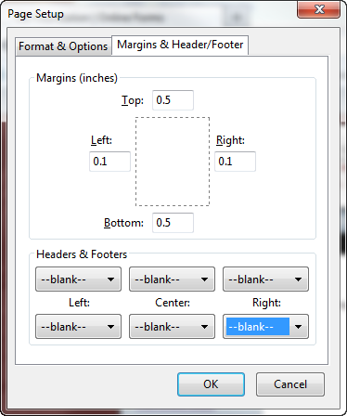
Adjusting the Print Settings in Chrome

Choose 'Print…' from the tools menu.
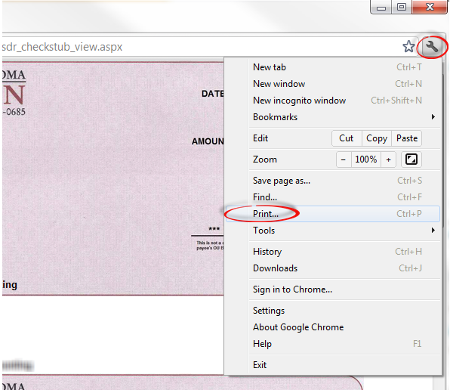

Uncheck the 'Headers and Footers' checkbox to prevent the date, page numbers, and Url from printing at the top and bottom of the page.
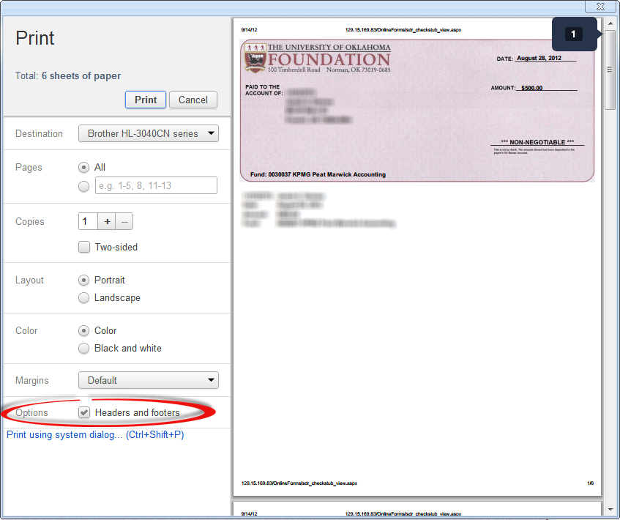

Adjusting the Print Settings in Safari

In Safari, choose 'Page setup' from the 'File' menu. This will take you to your printer settings dialog.
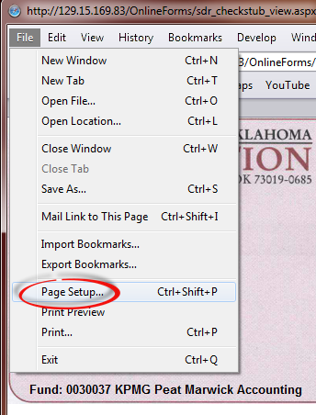

The dialog that appears will vary according to your printer type and driver version. On Windows you may not be able to prevent the header and footer fields (Date, Url, page numbers…) from printing.

Sponsor Access:

Signature Request Email

When a preparer requests signatures for a form, each sponsor will receive an email signature request like the one below. If your email client does not support HTML, you will receive a text version with links instead of button images.
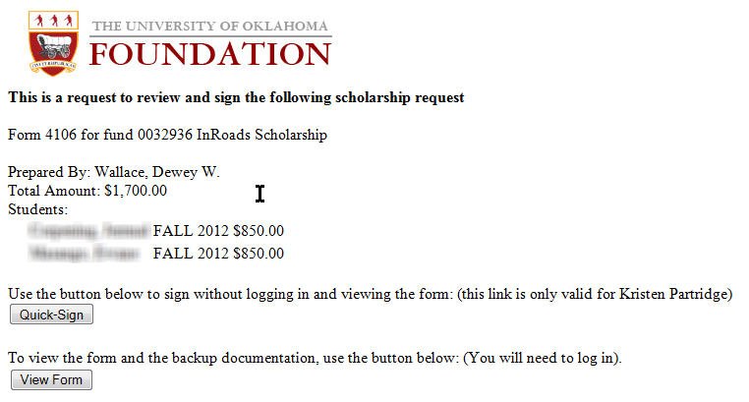

If you feel that the information provided in the email is enough that you would like to approve the request, click the 'Quick-Sign' button. You will be taken to a page where you may enter your signature without having to log on to the system (see the Quick-Signing section). If you want to view all of the details or you wish to decline to sign, click 'View Form' button. You will be taken to the form via the login page (see the next section: Signing the Form).

Signing the Form

Note: Changes have been made to the Online Forms to speed up the process of signing, saving and loading forms. Prior to these changes, when signing a form, the system validated your digital signature, saved the form, and notified the preparer and any following signers before sending you on to the next form. Now, once your signature has been validated, you will be sent on to the next form while the system continues to process the form in the background, thus speeding up the process of signing. Please keep in mind that part of the process of signing a form is to load the next form that is ready for you to sign. If the next form is a scholarship form with 75 students, it will take longer to load than a form with only 1 student. These changes have also improved the load time of even the larger forms and you should notice that the signing process is faster. In the event that something goes wrong in this background process, you will receive an email notifying you that you should return to the form and that you may need to re-sign it.
When a sponsor clicks on the link in the email notification, they are directed to the logon for online forms. When using the link in the signature request email, the preparer logon section is disabled.

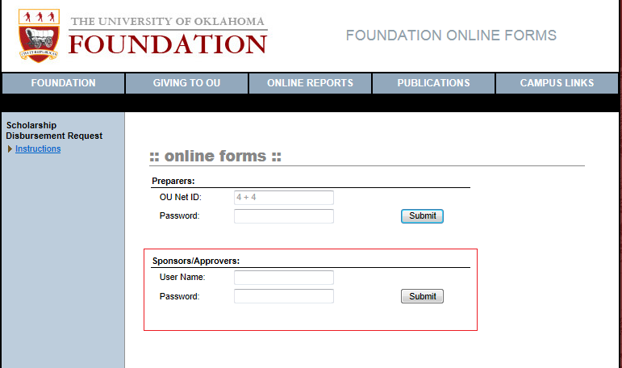
Sponsors/Approvers login with the same ID and password that would be used for the Foundation Financial Reports web site. Once successfully signed in, you will be directed to the form you have been requested to review and sign.
After reviewing the form, scroll to the bottom of the form and click the 'SIGN' button next to your name. You will be presented with the following dialog.
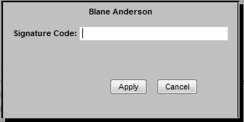

Enter your digital signature and click the 'apply' button. If the signature was successfully entered, the preparer will be notified that the form has been signed and the next required signer, if any, will be notified. If this is the last required signature, the preparer will be notified and the form will be submitted to the Foundation for review.

Once the form is successfully signed, the application will display the next form, if any, or return you to the form list.

If a sponsor prepares the form while logged in with their OU Net ID, the form may be signed without re-logging in with their Financial Reporting credentials. The dialog for signing in this situation will require an additional entry and appears as follows.

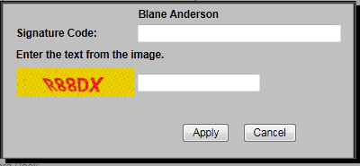

The code in the image must also be entered as well as the digital signature. This is to prevent automated programs from attempting to guess a sponsor's digital signature.

If while attempting to sign a request you receive the following response, you have attempted to sign with the temporary signature assigned by the Foundation. You will need to change your digital signature. See the next section.
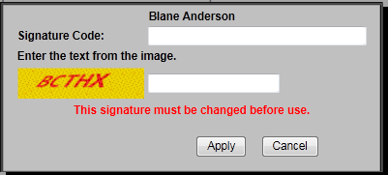

If while attempting to sign you receive the following dialog, you are attempting to sign a form that the preparer has not requested the signature. Be sure before signing the form that the preparer is done with the form or wait until the signature is requested.
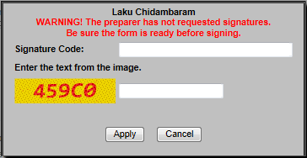

Once you have signed a form while logged in with your Foundation credentials, you will not need to re-enter your digital signature to sign additional forms. Until you log out, close your browser, or your session expires, your signature will be applied to the next form as soon as you click the sign button. This does not apply to forms where the preparer has not requested the signature. When you click the sign button on a form that the signature has not been requested, the signature code will always be required.
Quick-Signing the Form

Clicking on the 'Quick-Sign' button in the signature request email will bring you to the Quick-sign page.
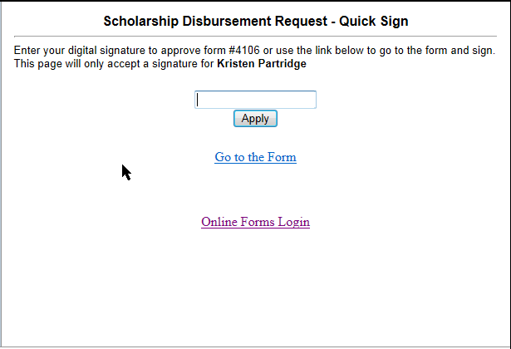

Enter your signature and click 'Apply'.
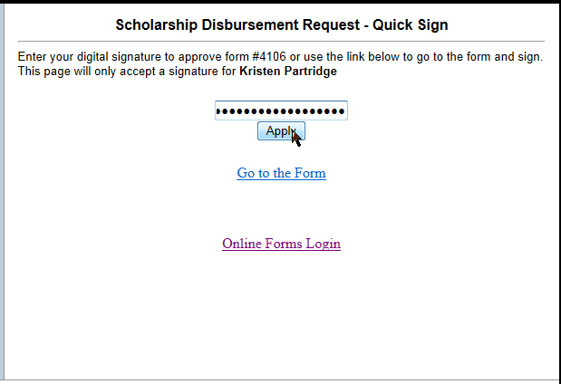

You will see a message indicating that your signature is being validated.
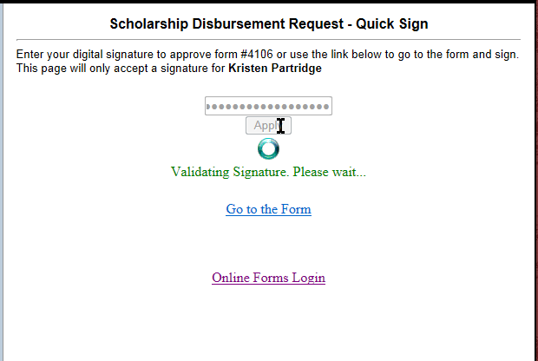

If your signature is valid, you will see the following indicating that you have signed the form.
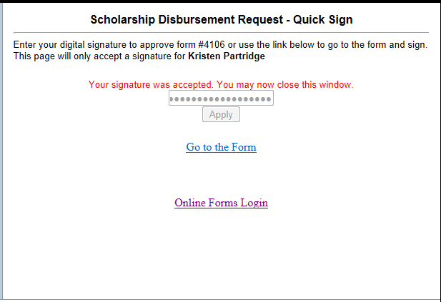

Declining to Sign

If you want to decline signature and send the form back to the preparer for changes, select the 'Decline' button next to your signature. You must be logged in as a sponsor for this button to enable.


You will be required to enter a reason for declining to sign.
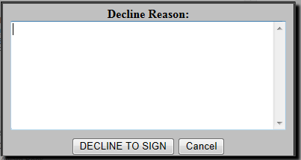
Once a reason is entered and 'Decline to Sign' is clicked, an email will be sent to the preparer notifying them the signature was declined. The email will contain the reason and a link to the form.
A link will appear next to the sponsor's signature area that will allow viewing the reason the signature was declined. The sponsor may update the reason from this link.

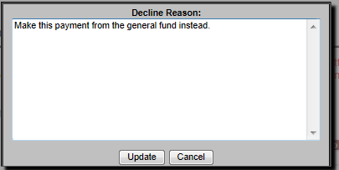
The 'Update' button will only appear for sponsors.

In the form list, form's that the signature has been declined will appear with a light-red background color.
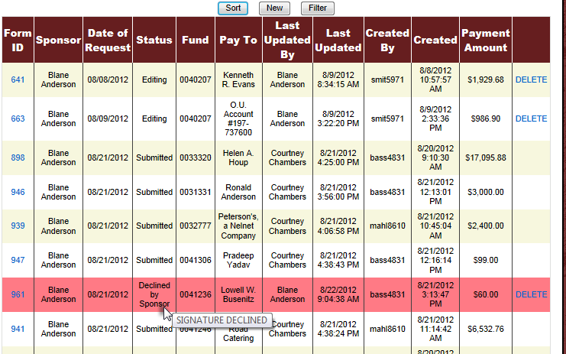

A form that has had a signature declined will also have a message at the top.
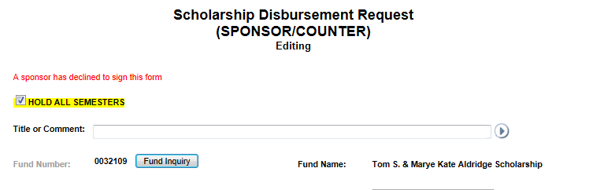

Clearing the Signature Declined status

To clear the declined status, the signature must be requested again or the form signed.
Changing your Digital Signature

To change your digital signature you must login to the Online Forms application as a Sponsor/Approver with your Foundation Financial Reporting user id and password.

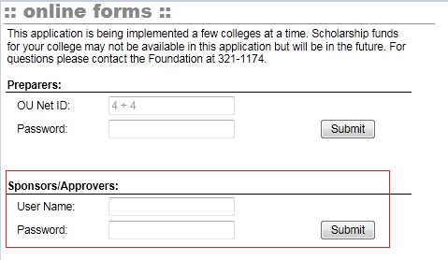

Once logged in choose the change signature option from the list on the left.
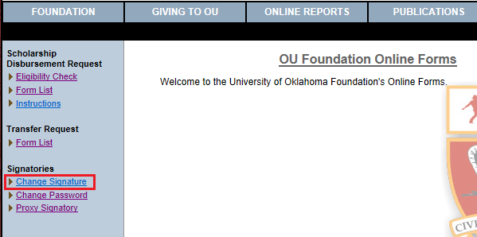

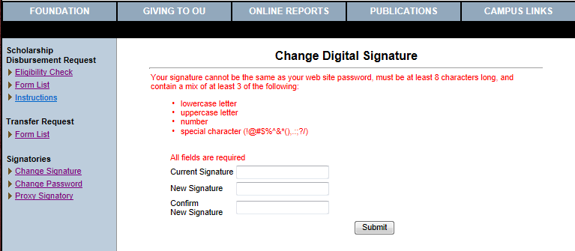

Enter your current signature in the box labeled 'Current Signature'. If you have received and email from the Foundation informing you of a temporary digital signature password, this is the digital signature password from the email. Enter your desired new signature in the next two text boxes and click the submit button. If your new signature meets the criteria outlined on the screen, your signature will be changed and an email sent to you informing you that your signature was changed.

Proxy Signature Authority:

Sponsors may tempoarily grant signature authority to another user. From the foms menu, choose the 'Proxy Signatory' item under 'Signatories'. You must be logged in as a sponsor to access this.
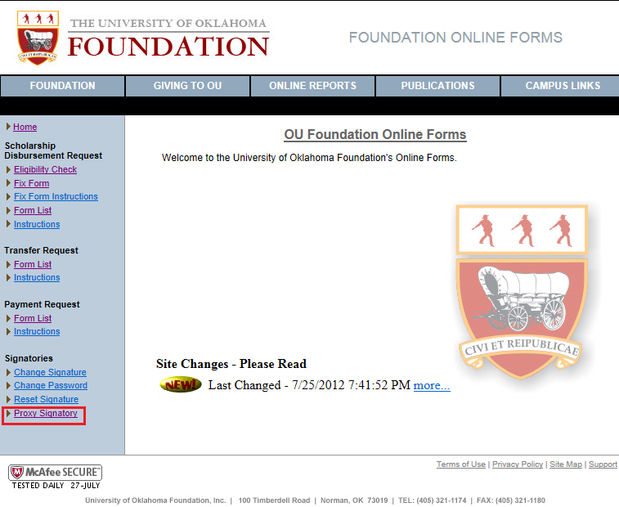

This will take you to a form list similar to the other online forms. Click the 'New' button to start a new proxy signatory form.
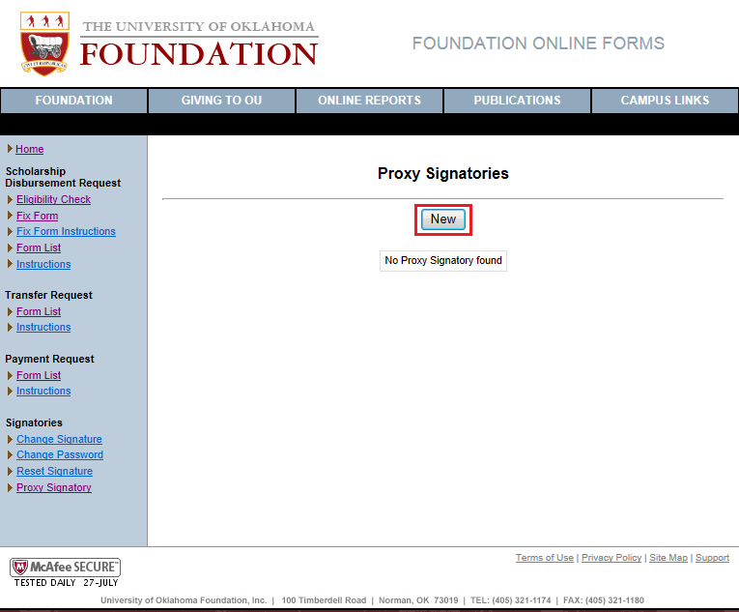

Begin typing the name of the person you wish to assign signature authority to. Select them from the drop down that appears. If you cannot find the person, they may not have a Foundation login. You will need to contact the Foundation to get them setup.
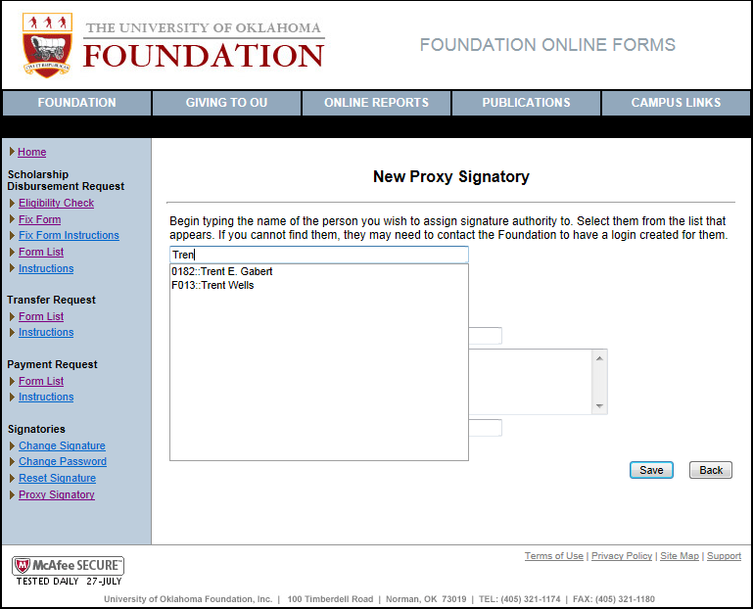

Enter the begin and end dates for the period you are granting signature authority. The maximum is 90 days. Enter the email of the person receiving signature authority. This person will receive an email with a temporary digital signature upon successful completion of the form. Enter your digital signature and click the save button.
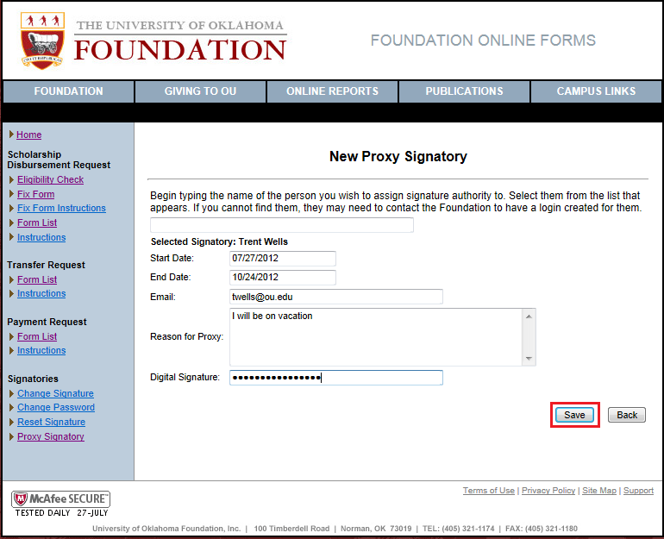

Once the form is saved it will appear in your form list. A copy will be added to the Foundation's document management system in the 'Documents' application. Click the ID to view or edit the form.
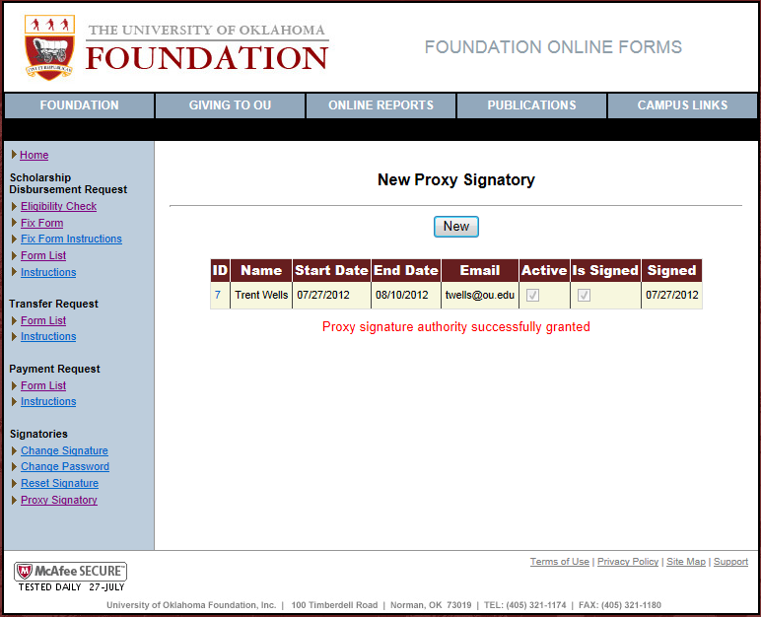

Any changes will require your digital signature to be re-entered.
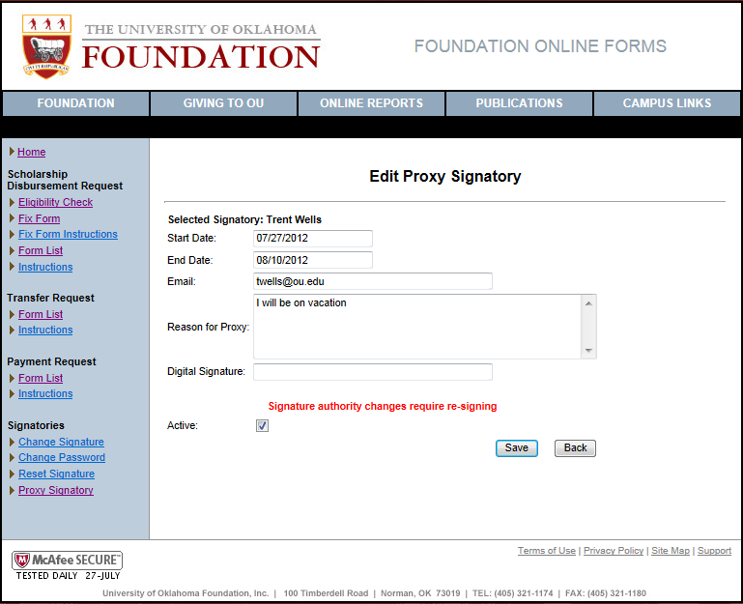

Search/View Processed Forms
The forms that you may search depend on how you are logged into the system. If you are logged in as a preparer, you will only be able to search forms that you prepared. If you are logged in as a reviewer, you will be able to search forms that you prepared as well as forms paying from funds in the colleges and departments for which you have been set up as a reviewer. If you are logged in as a Sponsor/Approver, you will be able to search forms disbursing from any fund for which you are a primary or counter-signing sponsor.

To search and view forms that have been processed by the Foundation, choose the 'Processed Forms Search' menu item in the Scholarship Disbursement Requests menu.
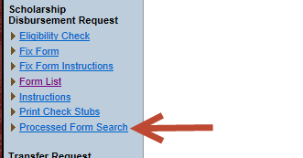
This will take you to the query screen. Enter your query criteria and click the 'Search' button. An explanation of the query criteria follows.
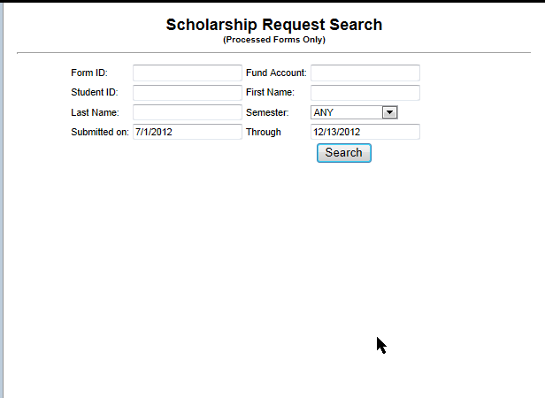

Form ID:
Enter the form number of the form you are searching for. If you do not know the form number or do not wish to limit the results to a single form, leave this blank.

Fund Account:
Enter the fund account number to limit the search results to only payments from the entered fund. The leading zeros are not required. If you do not wish to limit the results to a single fund, leave this blank.

Student ID:
Enter the student ID to search for forms containing a specific student.

First Name:
Enter the students' first name or partial first name to search for forms containing the text you entered in any students' first name.

Last Name:
Enter the students' last name or partial last name to search for forms containing the text you entered in any students' last name.

Semester:
Select a semester to only return forms having the selected semester. Leave the selection on 'ANY' to return forms containing any semester.

Submitted on:
These dates limit the query results by the date the form was submitted to the Foundation for processing. They will default to the current fiscal year. When these fields receive input focus, a date picker control will display to aid in entry of the date.
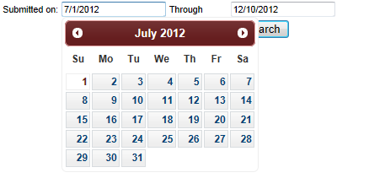

At least one query argument must be supplied and any combination of query criteria may be entered. The results are limited to a maximum of 100 forms. If your query results in more than 100 forms, you will see a message informing you of that but, the results will only display 100 forms.
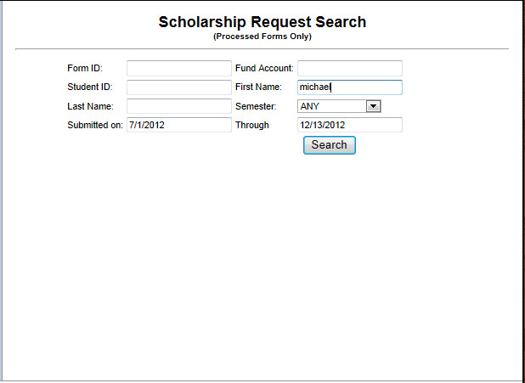

Once you receive the results, you may sort them by clicking in the column headers or navigate to the form by clicking the form id.
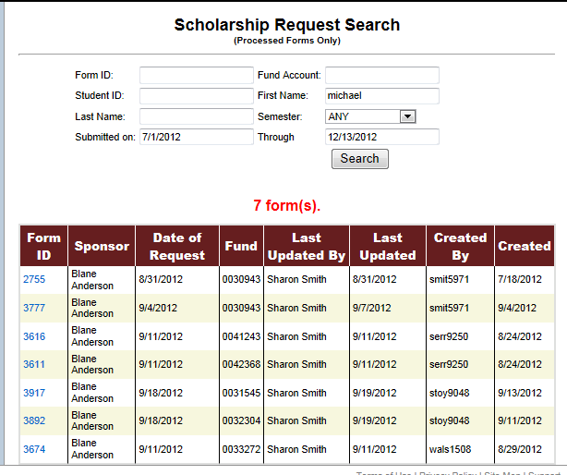
System Generated Notifications
You may instruct the system to periodically notify you of forms that have been on-hold and/or forms that have been waiting for signature. This is an opt-in process; no notices will be sent unless you request them.
From the 'Preferences' section of the menu choose 'Notifications'.
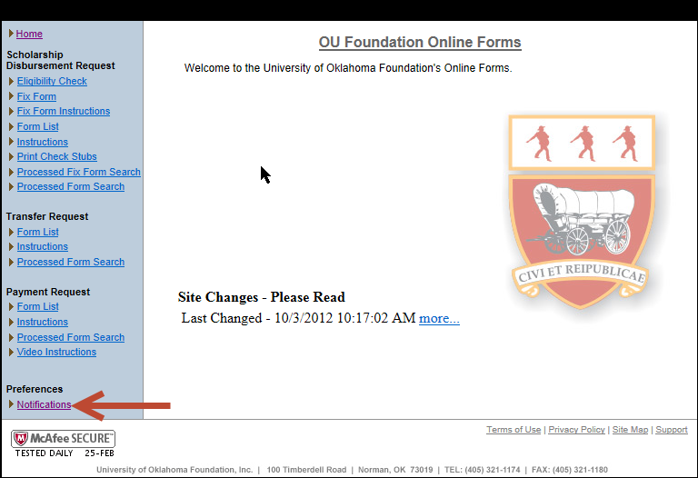

Preparer Notification Preferences
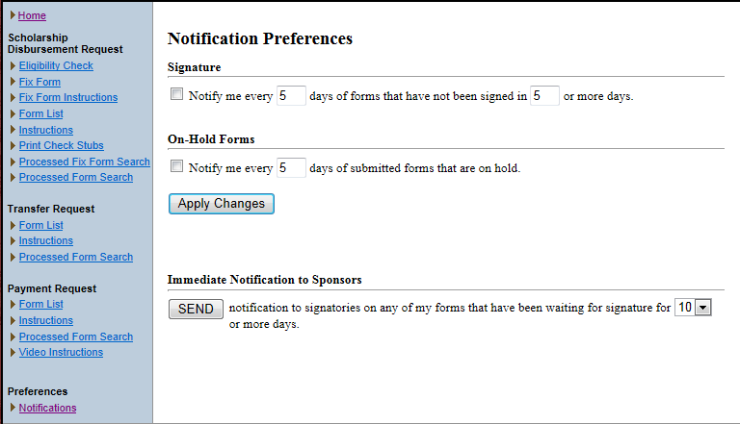

Signature Section
Check the checkbox in this section and click the 'Apply Changes' button to have the system send you an email every 5 days containing links to any online forms that have been waiting for signature 5 or more days. The setting for number of days may be changed to any number of days from 1 to 99. Uncheck the checkbox and click 'Apply Changes' to stop notifications. An example of the email that is sent is below.
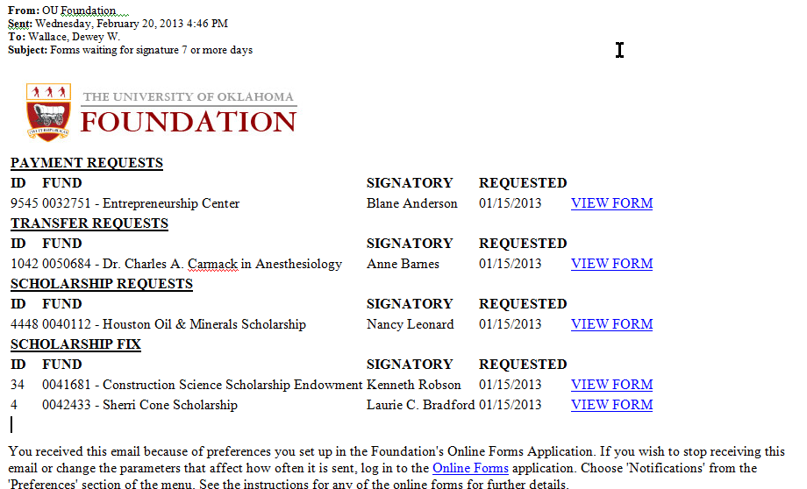

On-Hold Forms Section
Check the checkbox in this section and click the 'Apply Changes' button to have the system send you an email every 5 days containing links to any online forms that are currently on hold. The setting for number of days may be changed to any number of days from 1 to 99. Uncheck the checkbox and click 'Apply Changes' to stop notifications. An example of the email that will be sent is below.
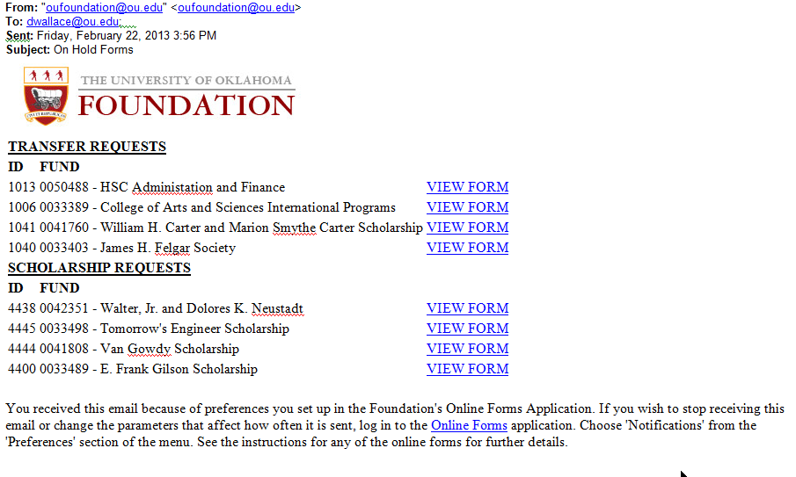

Immediate Notification to Sponsors Section
Click the 'SEND' button to have the system generate signature requests to sponsors. The system will check all of your forms for forms that have had signature requests and have not been signed in 10 or more days. You may change the number of days the form has been waiting for signature by selecting another value from the dropdown. The request email is the same as if you went to the form and clicked the 'Request Signature' button.
NOTE: If you have used this function in the last 5 days, you will get a popup confirming that you really want to send signature requests again.

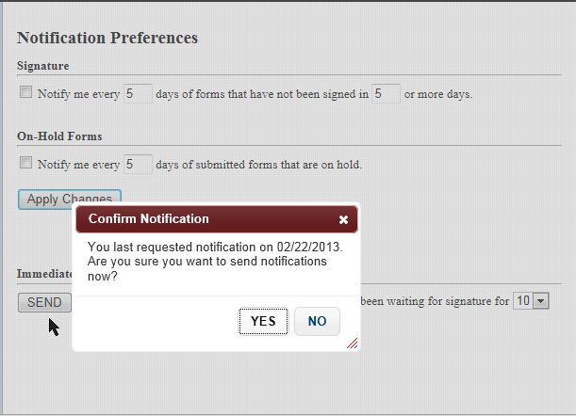

Sponsor Notification Preferences

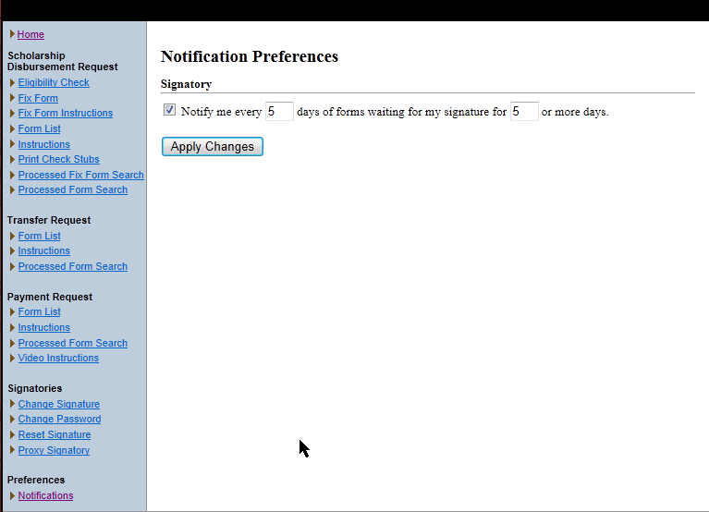

Signatory Section
Check the checkbox in this section and click the 'Apply Changes' button to have the system send you an email every 5 days containing links to any online forms that have been waiting for your signature 5 or more days. The setting for number of days may be changed to any number of days from 1 to 99. Uncheck the checkbox and click 'Apply Changes' to stop notifications. An example of the email that is sent is below.
